**CIE 337: Communication Theory**

**Project 2**

**1. Part A**

In this part of the project, we build a signal quantizer application using Matlab and build its GUI using Matlab’s AppDesigner.

The application interface:

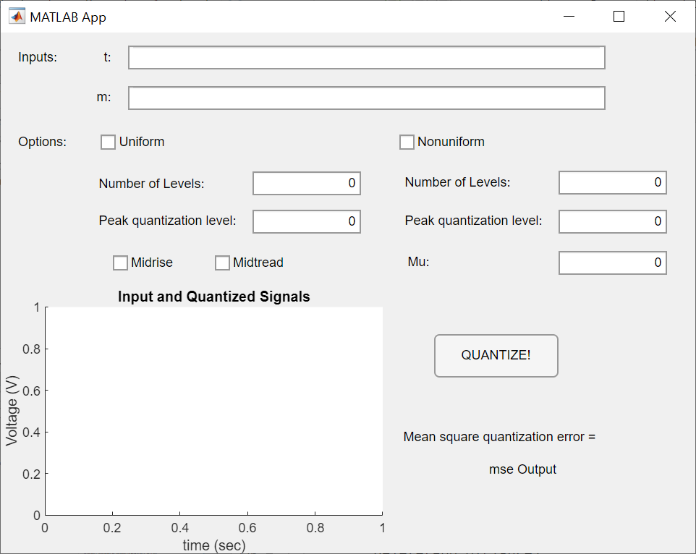

To quantize a signal m, the user must enter the signal and its corresponding time steps as arrays of doubles. The user then selects whether to perform uniform or non-uniform quantization and inputs each quantization type’s parameters. Finally, the user presses the “”QUANTIZE!” button and the application plots the input signal m and its quantized output on the “Input and Quantized Signals” graph and prints the resulting mean square error (MSE). The application also returns an array of the quantization steps, the quantized signal, and the MSE to the base Matlab workspace.

1. Uniform Quantization

To perform uniform quantization, the user has to input the number of quantization levels and the peak quantization level then select midrise or mid-tread quantization.

A simple example of midrise quantization:

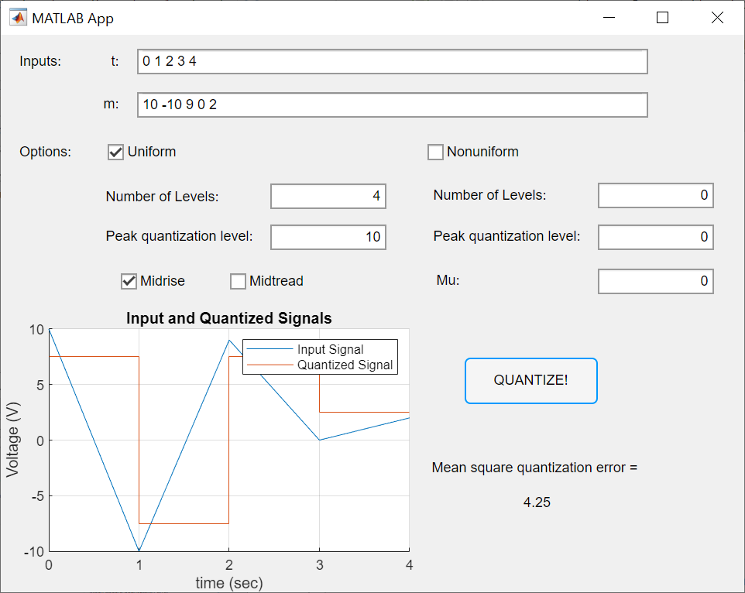

A simple example of mid-tread quantization:

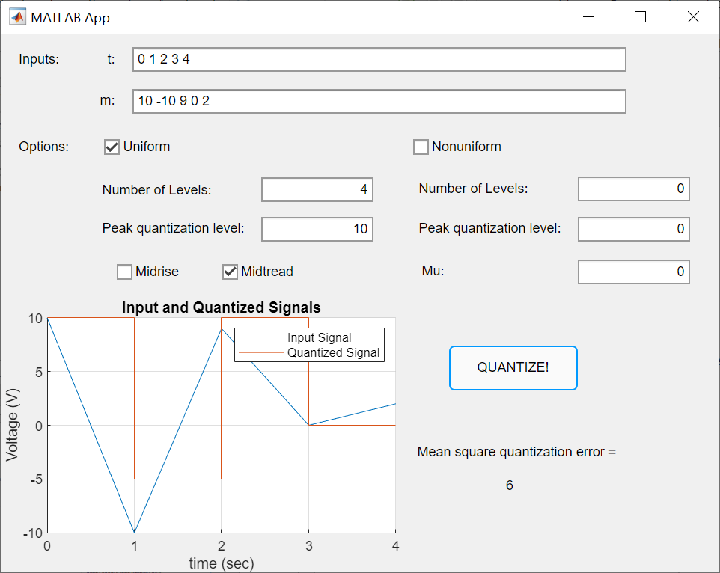

1. Non-Uniform Quantization

To perform non-uniform quantization, the user must input a value for mu, the number of quantization levels, and the peak quantization level. The application perform mu-law non-uniform quantization (mid-tread quantization where quantization steps are non-uniformly spaced).

First, the application normalizes the input signal and compresses it using the mu-law:

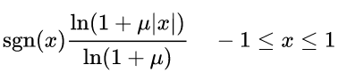

Then, the application performs uniform quantization on the compressed signal with a peak value of 1. Finally, the quantized signal is expanded using the inverse mu law:



The resultant is denormalized and plotted.

1. Test Examples

$$m=5cos⁡(2π10t)$$

$$t= -\frac{1}{20}:\frac{1}{20} sec$$

Note: while the project description requires we take just one cycle of the signal, stopping at exactly 1/20 seconds usually leads us to take 1 extra point from the next cycle. Although in some cases this hugely affects the resultant MSE, we assume that’s fine because the sampling frequency is too low and we can’t really give up this one point.

* Sampling frequency = 40 Hz, mu = 0, L = 8, mp = 5:

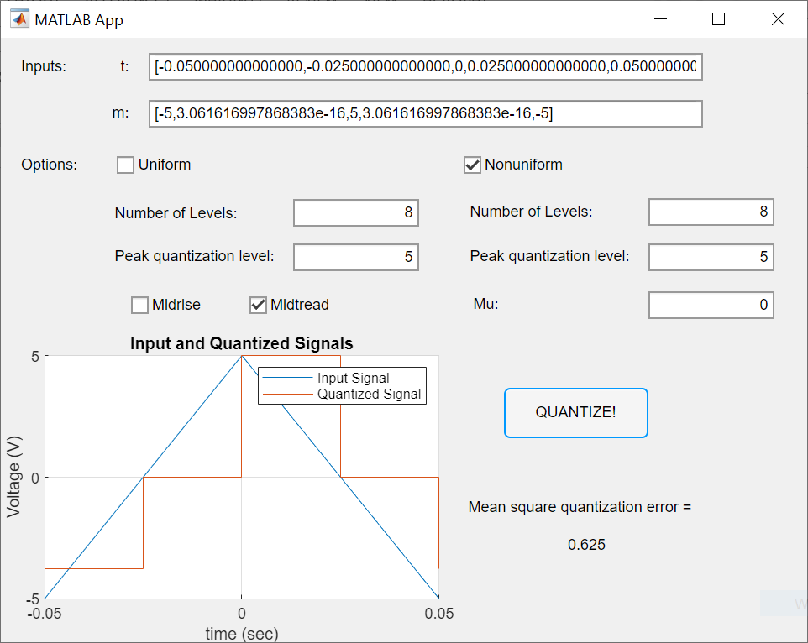

With mu = 0, this case applied typical uniform mid-tread quantization. Since we have an even number of steps, the points with value = -mp did not have a step exactly equal their value and thus were quantized to a larger number leading to a significant error.

* Sampling frequency = 20 Hz, mu = 0, L = 32, mp = 5:

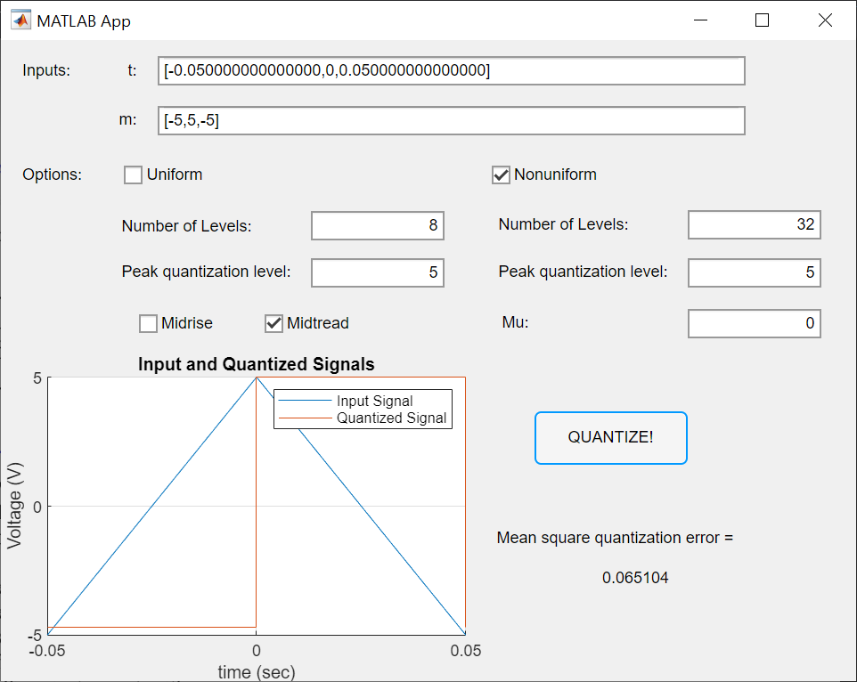

Again, this is an application of uniform mid-tread quantization. The large number of steps made the quantization of points at -5 almost accurate leading to a small error.

* Sampling frequency = 15 Hz, mu = 0, L = 16, mp = 5:

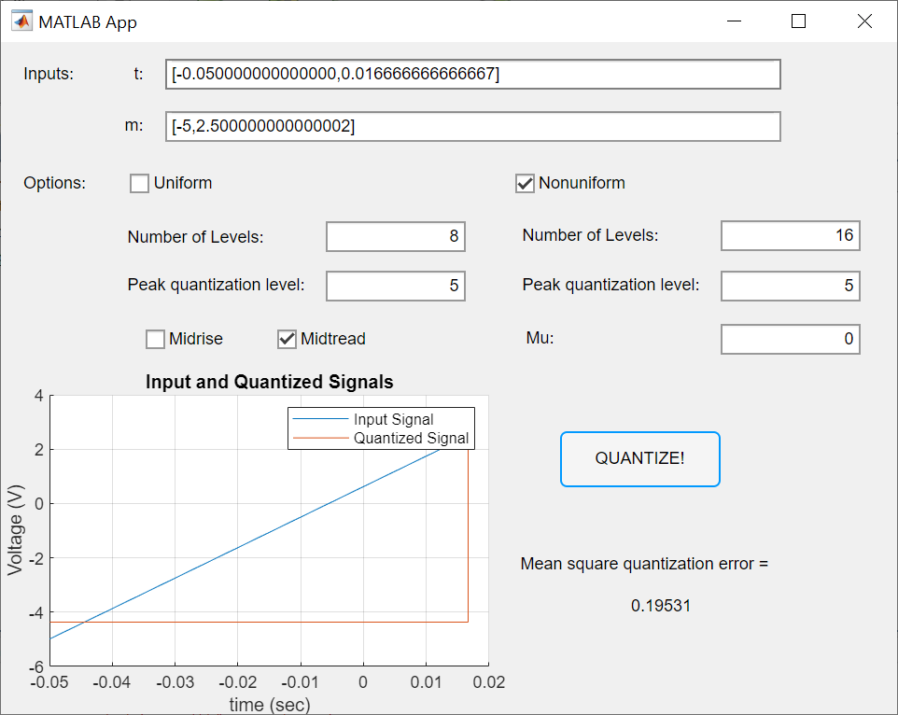

Yet another uniform mid-tread quantization! Because of the extremely low sampling frequency, only two points from the cycle were considered. Again, the error results from the point at -5 V. This error lies between the errors of the two previous cases, since the number of levels 16 is larger than the number of levels in case 1 and smaller that in case 2.

* Sampling frequency = 20 Hz, mu = 100, L = 32, mp = 5:

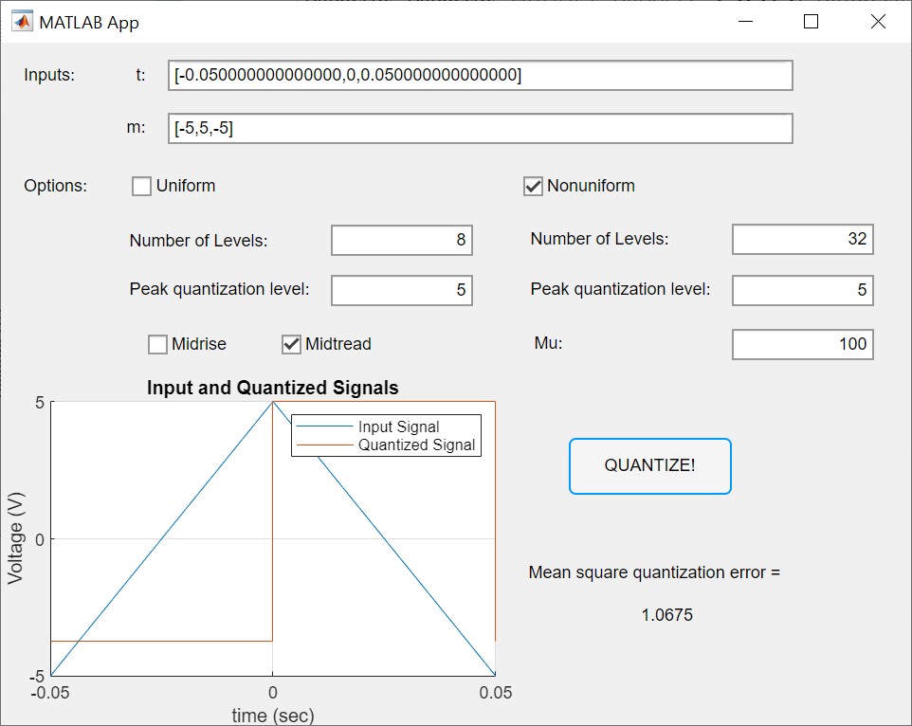

Here we do use a nonzero value of mu! Yet, the error is incredibly huge because the since all three values of this case are equal negative or positive the peak value, where quantization steps are most sparse.

**2. PART B**